# **Symbiosis School, nashik**

ART AND CRAFT ACTIVITIES

GREAD:- VII To X

TOPIC:- GEOMETRIC DESIGN ART

## HOW TO CREATE GEOMETRIC DESIGN ART

Here are the basic steps to creating geometric art:

You can pick your favourite animal or any other picture of choice.   
  
 We found a beautiful [fox image](https://pixabay.com/photos/fox-mammal-predator-nature-wild-4177951/) that didn’t have any body parts hidden by grass or any another object, and also had enough contrasting colours to be easy to work with.

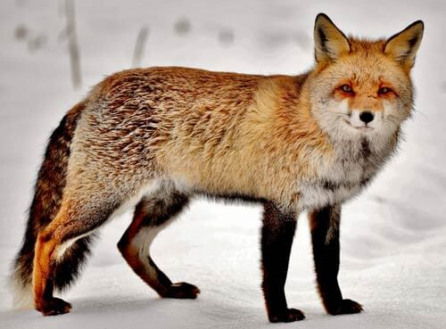

Print the photo if it’s digital, or **cut out**er image if it’s in a magazine.

If you have a photo editing software, you have the option of sizing the photo to whatever dimensions desired. If not just print out as is.

Now tress your picture on drawing sheet with the help of tress paper.

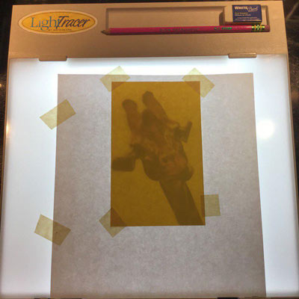

You’re going to redraw the outside of your image with only straight lines. A small ruler will be very helpful.

Since we are doing geometric art, this won’t be exactly like the image. You can decide to do more lines to more closely resemble the animal, or less lines for a simpler effect.

Using your ruler, trace these areas making sure all lines are straight.

For example, in the fox image, chose to outline the head, and distinguish the hind leg from its tail. Of course this is optional and up to each artists artistic choice.

Common geometric shapes are triangles, rectangles, and other 4 sided polygons.

You can choose to do smaller shapes which will mean there are more shapes, or bigger shapes which means there will be less of them.

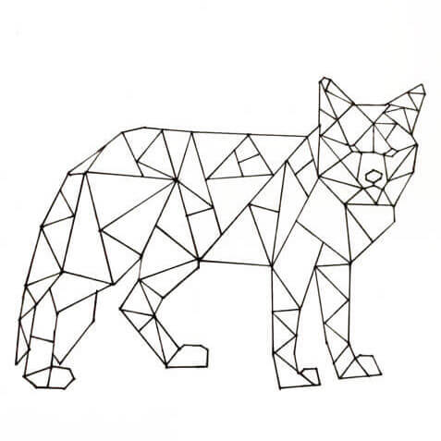

Now choose 3 – 5 colours for colouring the fox. and then coloured each of the geometric shapes of animal one of those colours.

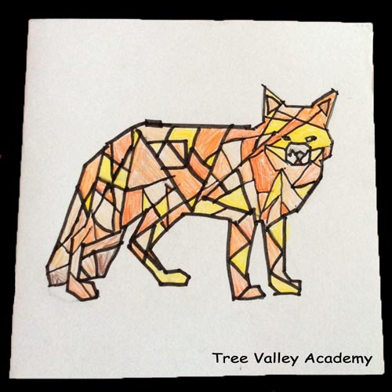

**●FOR MORE DETAILS REFER THE GIVEN LINK** <https://youtu.be/mJ0FaHNKGaM>

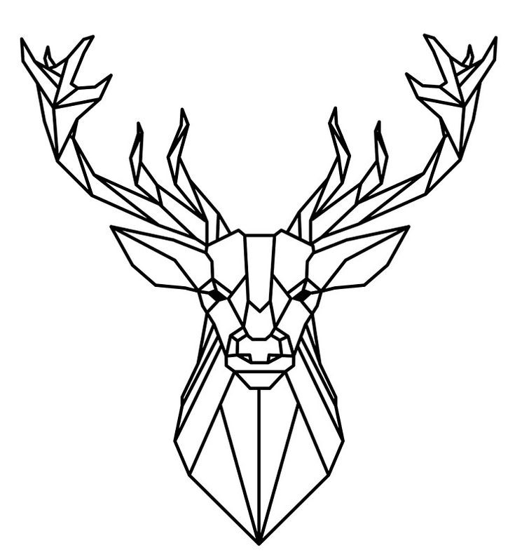●REFERENCE DRAWING

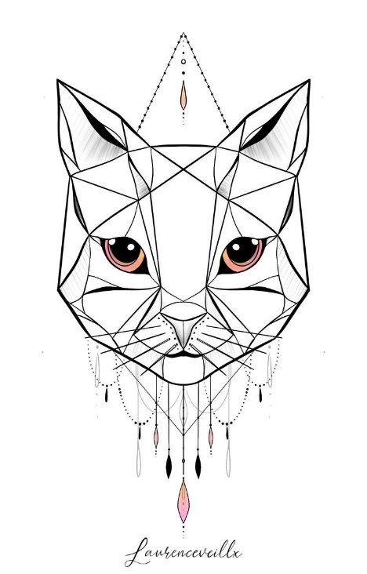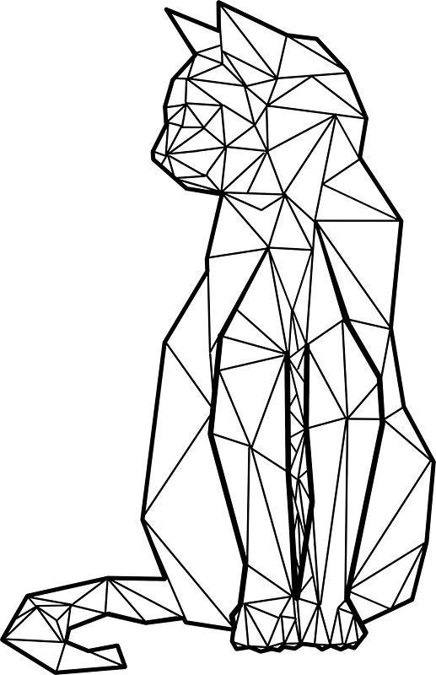

●REFERENCE COLOUR PICTURES

